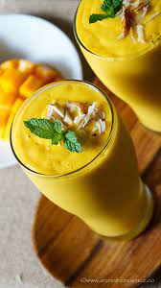
Mango Lassi

INGREDIENTS

- 5 cups canned mango pulp
- 4-5 cups yogurt plain whole milk yogurt
- 2 cups milk (cold) to thin out the lassi or use water
- 6 tablespoons sugar or adjust to taste
- 1 teaspoon cardamom powder
- saffron strands to garnish, optional
- dry fruits to garnish, optional

INSTRUCTIONS

- To a blender, add the mango pulp from the can and blend it out.
- To the blender now add the yogurt. Vegan yogurt can also be used.
- Followed by milk (preferably, whole milk) or Water. Add this to thin out the lassi a bit. Also, add sugar and cardamom powder.
Blend for around 60 seconds until everything is well combined. Pour the lassi into serving glasses and top with saffron strands (optional). You can also garnish with nuts

